GUIDANCE NOTES

1. MEETING POINT

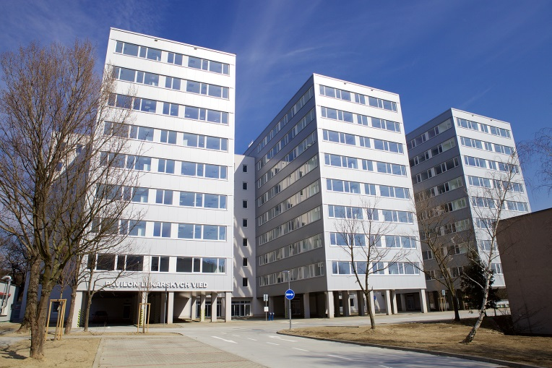

Cancer Research Institute of Biomedical Research Center SAS
(„Pavilón lekárskych vied“)
Dúbravská cesta 9
845 05 Bratislava

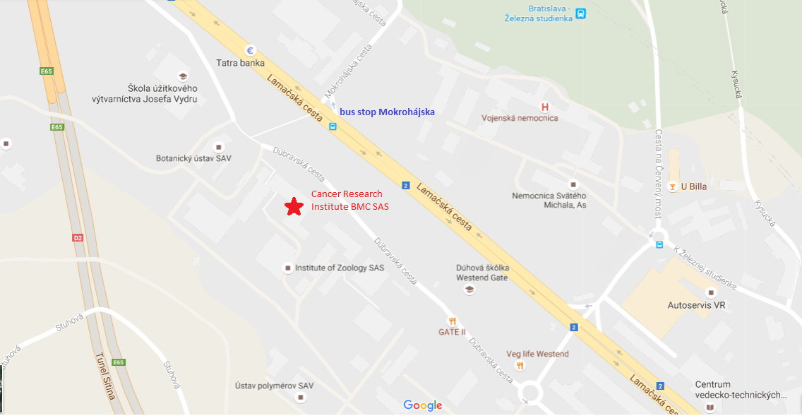

2. Accommodation

These are some of the hotels in the proximity of the Meeting Venue:

Max Inn ***
http://maxinn.sk/en/

Mercure Bratislava Centrum Hotel ****
http://www.mercure.com/gb/hotel-6840-mercure-bratislava-centrum-hotel/index.shtml

Hotel Tatra ****
http://www.hoteltatra.sk/en

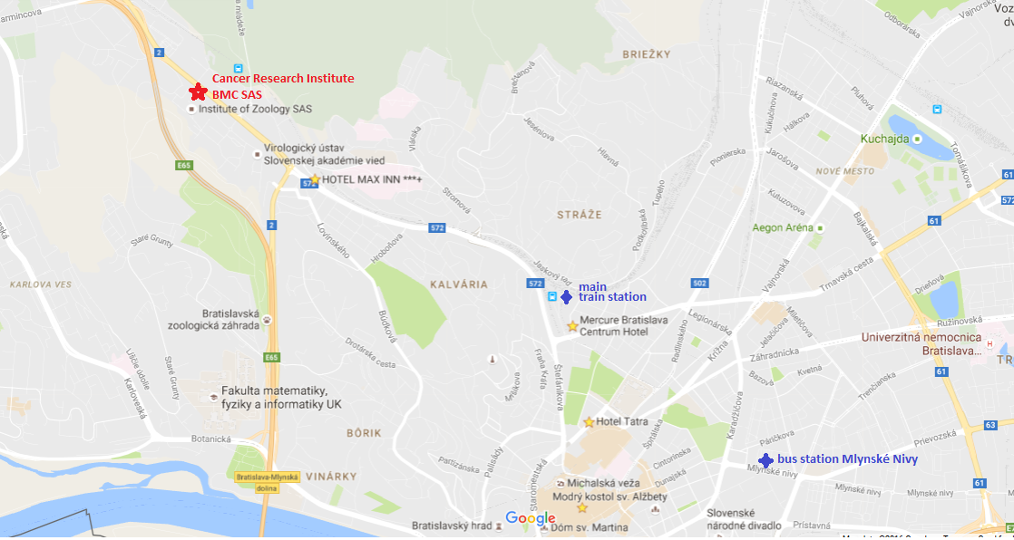

3. Getting from the Airport to Hotels
If you are flying to Vienna International Airport, take a bus to Bratislava (with the final stop at Main Bus Station Mlynske Nivy – check it with the driver). Bus stop is located in front of the arrival gate (bus stop 4). Ride lasts around 50 minutes, and costs about 9€. At the bus station Mlynske Nivy, take a public transportation (bus or trolley bus) to get to your hotel. Please check the website and find the best option to get to your hotel:
https://imhd.sk/ba/public-transport

If you are flying directly to Bratislava, bus stop of the bus #61 is located in front of the Airport (last stop is the Main Railway Station where you can transfer to another bus line).
You will have to buy a ticket (60 minutes, price 1.30€) and validate it in a bus in the yellow marking machines immediately after entering the vehicle (otherwise you may get a fine).

4. Local Transport
If you need to move in the city, you can either use bus, trolley bus or tram
http://www.dpb.sk/en/passengers/schedules/

Depending on where you are staying, you may need a bus to get to the venue – bus stop Mokrohájska is operated by line 21, 30, 83, 84. Please, check the best option for you. After getting off the bus, cross the road and follow the path through the park for 5 minutes, and you will get to the campus by the secondary entrance. Signs will guide you to the Institute.
If you are driving to the Meeting Venue, enter the main entrance of the campus of Slovak Academy of Sciences located on Dúbravská cesta 9 and follow the sign for „Pavilón lekárskych vied“. It is the new building located next to the Institute of Virology and Zoology. The parking is available in front of the building.

